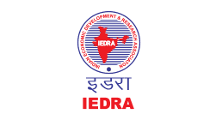

The Indian Economic Development & Research Association (IEDRA) & IEDRA International Division

&

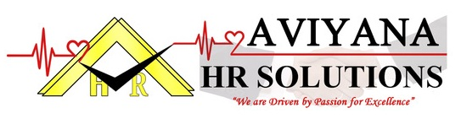

Presents

Aviyana National & International HR Awards

Aviyana National HR Awards - 25th July 2020
At India Habitat Centre, Near Air Force Bal Bharati School, Lodhi Road
Lodhi Estate, New Delhi - 110003

Aviyana International HR Awards - 29 August 2020
At Holiday Inn, Silom Road, Bangkok, Thailand

Form for Award Nomination

Award Applying for:
(Mention Award Name from List)

Name:

Educational Details:

Designation:

Company Associated with:

Company Address:

Pin Code:

Phone No’s:

Fax:

Email:

Awards & Honours Received:

Do submit a writeup with support documents as available as to why you or your organisation is suitable for Organisational/Individual/HR Consultancy award categories

Mail the form and all supportive details on connect@aviyanaventures.com
Coordinator Ms Nida. Ansari: 9967132143
Connect for National HR Awards - Ms Harmeet: 8433680857
Contact for International HR Awards - Ms Shivani Gupta: 8433680856/65

